CNIP for VoIP
a Swisscom Directories AG brand

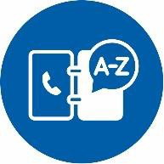
CNIP – Know who’s calling! With “Calling Name Identification Presentation” (CNIP pursuant to ITU-T Recommendation I.251.9), it is possible to see not only the caller’s number but also their name and place of residence when receiving incoming calls. Telecom providers can use the service to offer their customers a clear additional benefit while also meeting their legal responsibility to help reduce nuisance marketing calls.

CNIP DIRECTORY DATA
INTEGRATION OPTIONS

The CNIP service from directoriesDATA is based on the entries published in Switzerland’s public telephone directory (approx. 2.6 million entries). It contains the names and addresses of people and businesses. This data can be used for automatic caller identification and display on IP-enabled telephony devices (including mobiles).
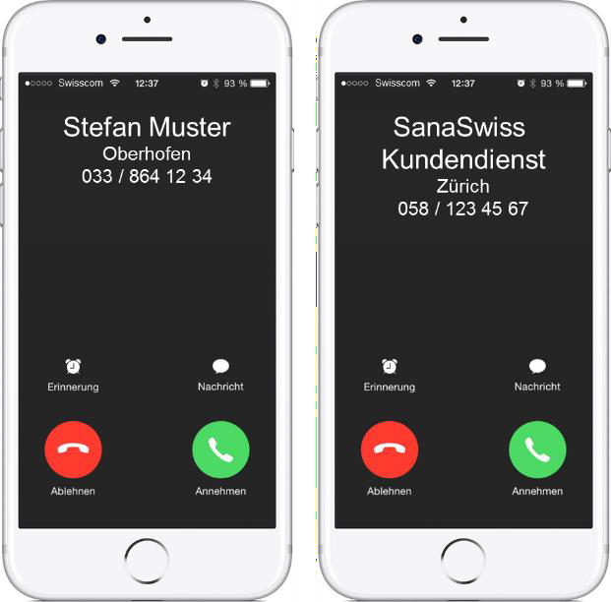

DATA CONTENT
From the directory data, the following up-to-date attributes are made available:

- First name and last name or business name
- Street and house number
- Postcode/city
- Caller number

Owners of phone numbers can request the following measures from directoriesDATA:

- Prioritisation in the case of multiple entries
- Withholding CNIP information completely

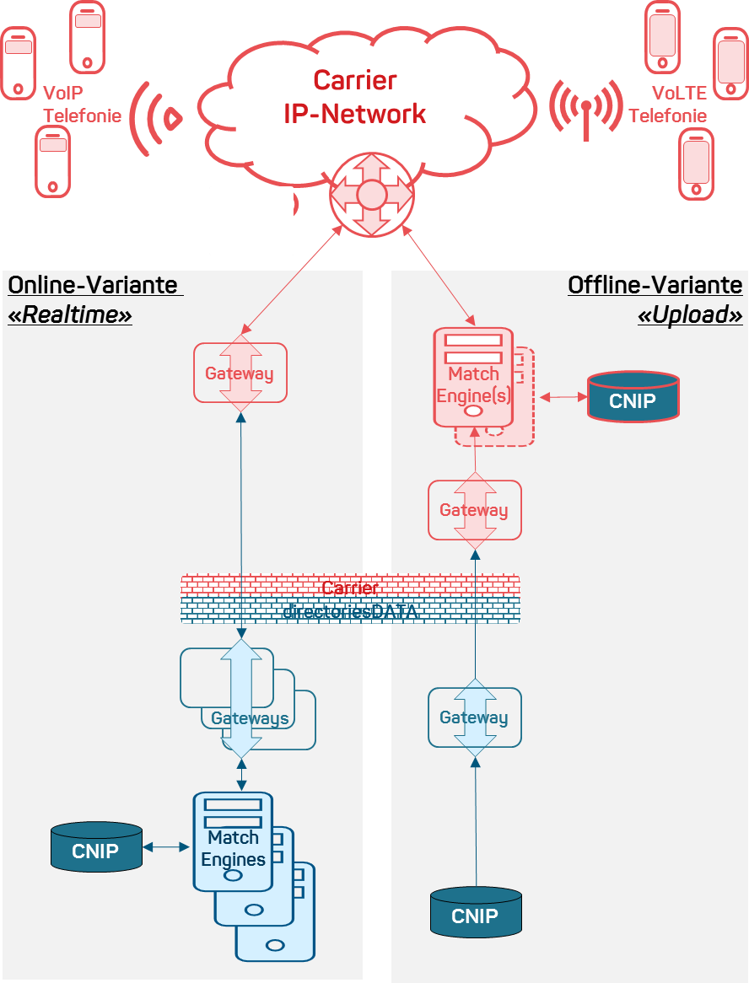

VoIP Telefonie | VoIP telephony
Carrier IP-Network | Carrier IP network
VoLTE Telefonie | VoLTE telephony
Online-Variante „Realtime“ | Online version “real time”
Offline-Variante „Upload“ | Offline version “upload”
Gateway | Gateway
Match Engine(s) | Match engine(s)
CNIP | CNIP
Carrier | Carrier
directoriesDATA | directoriesDATA

The online option is an XML interface that can be queried in real time during signalling in the carrier network. With this option, entry data for the signalled number is determined using the match engines of directoriesDATA. The match engine and gateway capacities are determined on the basis of the anticipated query volume. We offer the option of a shared gateway (best-effort response time usually <1 sec.) or a dedicated gateway (guaranteed response time <1 sec. at up to 1,000 concurrent users).

With the offline option, directoriesDATA makes up-to-date CNIP data available via an SFTP interface. The carrier is free to configure the service capacities (response times/availability), but it must provide its own match engines for this purpose. Suitable for carriers with more than 100,000 customers.

BENEFITS

- Convenience for your customers
- Helps to reduce nuisance marketing calls
- Quick and easy to set up
- Data management and back office support from directoriesDATA
PURPOSE

The provided CNIP data must only be used for the purpose of caller identification and display on IP-enabled devices.
PRICING

Online version:

- Initial set-up fee: CHF 2,500
- Per IP-enabled customer connection: CHF 1.50/year
- Infrastructure fees
  - Shared gateway/Match engine:

CHF 800/month
(Response time: best effort usually <1 sec.)
  - Dedicated gateway/Match engine

CHF 4,500/month
(Guaranteed response time: <1 sec. at up to 1,000 concurrent users)
  - Further service capacities/options on request Offline version (suitable for large customers):
- Initial set-up fee: CHF 3,500
- Per IP-enabled customer connection: CHF 1.50/year

All prices are quoted without VAT
and are subject to change.
QUESTIONS & ADVICE

The directoriesDATA team looks forward to hearing from you and will be pleased to answer any of your questions.

Email: contact@directoriesdata.ch Phone: 0800 88 99 77

